Capture ping and topology Session 10

1. Topology

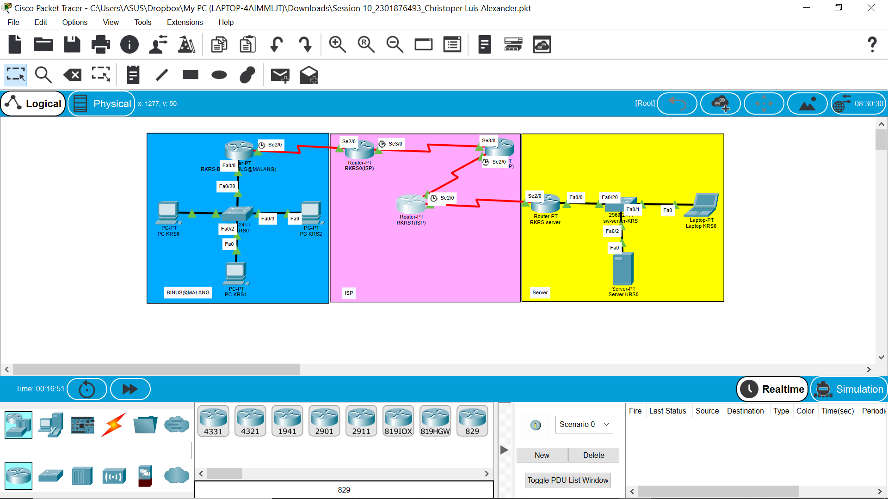

2. Ping

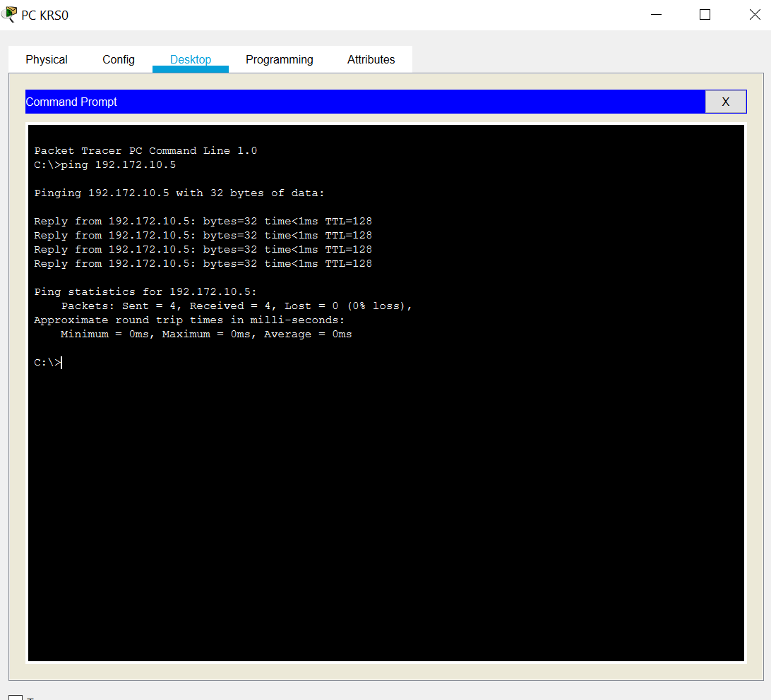- PC KRS0 ke Server KRS0

- PC KRS2 ke Laptop KRS0

